|  |  |  |
| --- | --- | --- |
| **LAB221 Assignment** | **Type:** | **Short Assignment** |
| **Code:** | **J2.S.P0120** |
| **LOC:** | **50** |
| **Slot(s):** | **1** |

**Title**

Edit tree node using combo box

**Background Context**

In fact, sometime we can also need to perform custom editing of any item in a tree control. JTree supports three techniques for editing tree nodes.

* The easiest is to simply call the setEditable(value) method and set the value to be true

In this mode, the tree values are editable using a simple text editor.

* The second technique is to create a real custom editor for the tree, and this is what we will do in the EditTreeExample.java example below.
* The third technique for tree editing is to replace the DefaultCellEditor() reference in EditTreeExample.java with a class that implements CellEditor. Refer to the online Swing documentation for details about the CellEditor implementation

**Program Specifications**

Create a program to allow user edit all nodes in a tree, values are used to update nodes get from a list

***Function details:***

1. Create a tree
2. Edit a node base on a list of values stored in a combo box

***Expectation of User interface:***

The screen should be as:

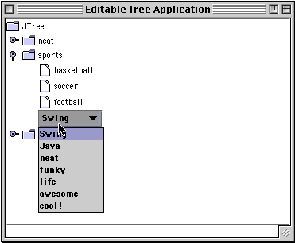

**Guidelines**